Legendary Bordeaux: The Stories of Bordeaux’s First Growth Wines
BY ROGER VOSS. the wine enthusiast
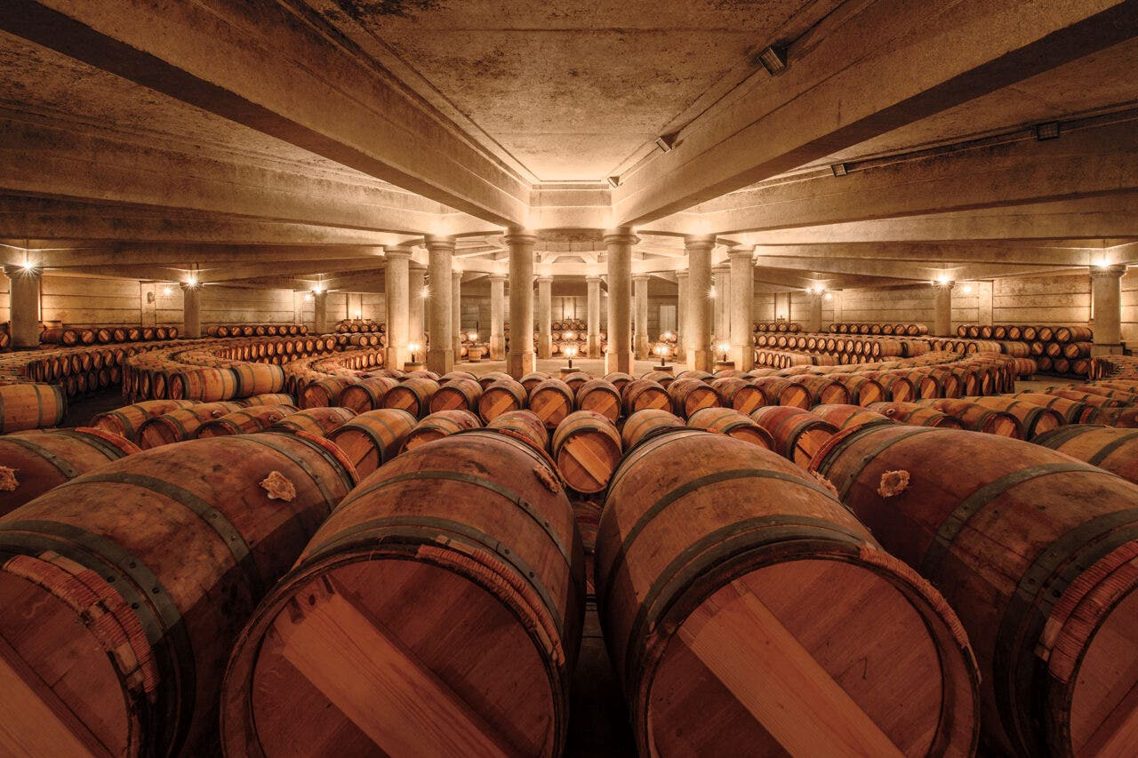
Château Lafite-Rothschild / Photo by François Poincet

Since the 1855 classification, the first growths of Bordeaux Médoc and Graves have stood at the top of the heap, the monarchs of all they survey. Other chateaus, however good, can aspire to, but never seem to reach, the pinnacle of these five (originally, four).
Chateaux Lafite-Rothschild, Mouton Rothschild, Latour, Margaux and Haut-Brion: What sets them apart? What magic stardust has been sprinkled on them to offer such enduring status?
The alpha and omega is the terroir. All five have magnificent vineyards. The richness of the gravel and clay makes a natural home for Cabernet Sauvignon, the premier grape for all five. Owners may have come and gone, but those vineyards remain treasured.
Over the decades, the soil and vines have been observed, fussed over and analyzed almost to excess. Every wrinkle is known and, increasingly, understood. That attention to detail has translated into the cellar and the wine.
Climate change has increased the need for observation. Sandwiched between the Gironde estuary and the Atlantic Ocean, the Médoc-based first growths have seen little change so far. In fact, at Mouton and Lafite, they glory in the increased ripeness of the Cabernet Sauvignon and its higher percentage of the blend.
But these titans are also planning for the future. At Château Margaux, when vines are replanted, they’re now oriented away from the sun, and Merlot is replaced with Cabernet Franc.
These are multimillion-dollar businesses. They sell wines at prices above the market, and they promote them stylishly and effortlessly. But they owe their success to what goes into the land, and what comes out of it. Keep reading to learn more about how they keep their legacies strong.
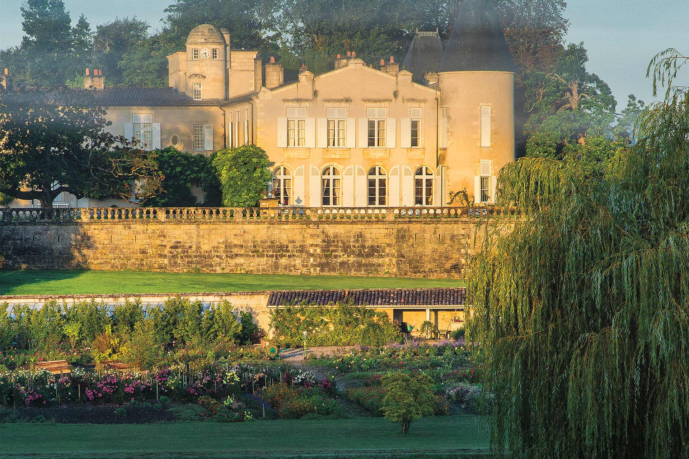Château Lafite-Rothschild / Photo by François Poincet

Château Lafite-Rothschild

The Iron Fist in the Velvet Glove
Standing in the courtyard of Château Lafite-Rothschild, one must turn away from the structure to look at one of the most dramatic vineyard sites in the world. Rising steeply in a majestic curve, known as the Dome, are rows of Cabernet Sauvignon vines. They climb up to the plateau that forms the heart of Lafite’s Grand Vin, its first wine.
Of the 276 acres of vines that form the estate, this 172-acre core is where Château Lafite-Rothschild’s Grand Vin is produced.
“It has a very special composition,” says Eric Kohler, the technical director since 2015. “It is on a plateau, deep gravel mixed with clay. That mix balances the water when it is needed in the summer.”
The vineyard has remained unchanged since the French branch of the Rothschild family bought the estate in 1868.
“While we have enlarged the estate for our second wine, Carruades, the Grand Vin vineyard is very stable, with many vines that are over 50 years old,” says Kohler.
He arrived in 1992. Since then, he says that 75% of the changes have been in the vineyard, with drainage and better observation of the vines.
“We are now effectively organic, although we do not want to be certified,” says Kohler. “In 2019 and 2020, we were totally organic.”
Lafite is the expression of its terroir each year, a wine that ages even though recent vintages have seemed more accessible when young.
“The wine is a subtle blend of power and softness,” he says. It would be easy to make a powerful wine, “but we want the softness with the power in the background.”
As the percentage of Merlot in the Grand Vin blend falls, currently no more than 8%, the need to control the natural power of the Cabernet Sauvignon increases.
Alcohol levels are always modest at Lafite. This year, the final blend will likely be 13% alcohol by volume (abv). That modesty comes from the same aim. Lafite is a wine that has force, but it always retains that softness.
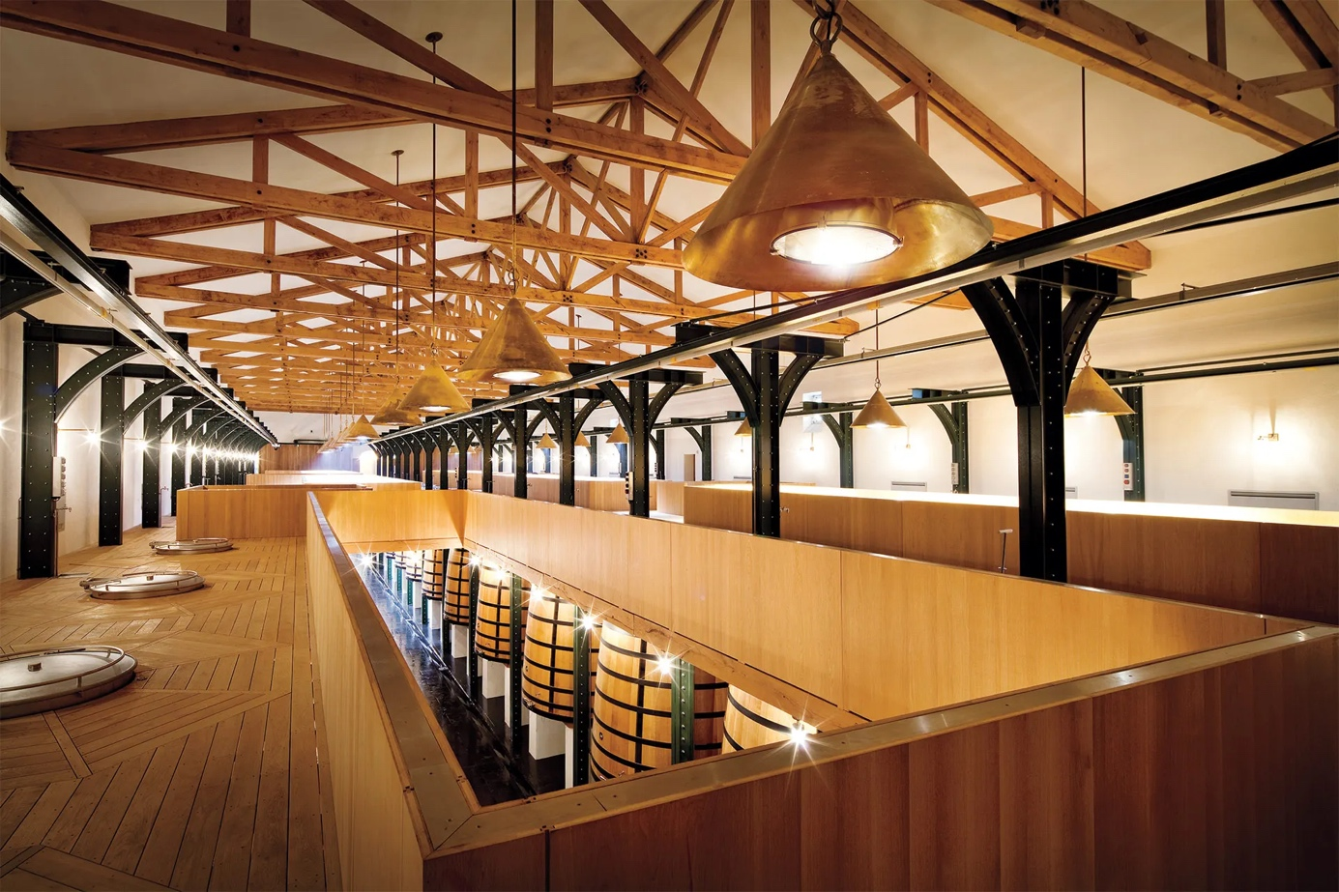Château Mouton Rothschild / Photo by François Poincet

Château Mouton Rothschild

Opulence and Velvet Tannins
Château Mouton Rothschild is the sunniest of the first growths, the most opulent and the richest. It has always been like this, sometimes excessively so. Today, it’s more restrained and succulent.
Of course, it’s all down to the vineyard, some 200 acres planted in gravel that’s up to 22 feet deep in places, with a chalk subsoil.
It’s the highest point in Pauillac (all of 80 feet above sea level) with two plateaus of vines, one close to the chateau called Le Grand Plateau, and the other named Le Plateau des Carruades. A small dip between the two gives a pause in this intensity of vines and gravel.
Mouton Rothschild was not among the four first growths in the 1855 classification. It became a first growth in 1973, after decades of lobbying by owner Philippe de Rothschild. It’s easy to question why it was not classified as a first growth. Remember, the classification was based on sale price, not necessarily the quality of the wine.
“The secret of Mouton is the vineyard that has stayed the same since the [English branch of the] Rothschild family bought it in 1853,” says Philippe Dhalluin, the retiring managing director who will hand over the reins to Emmanuel Danjoy, the technical director. “The Grand Plateau is precocious. It gives tannins that are soft and fruit that is sweet.”
Like all the Médoc first growths, Mouton is about Cabernet Sauvignon. It can be more than 90% of the blend.
“Along with our terroir, the Cabernet gives these intense but velvet tannins, and the richness that you can see even two days after fermentation starts,” says Danjoy. “It gives flavor, finesse and the perfumes that come from every tank in the cellar at harvest time.”
It’s a supreme example of the blissful marriage of gravel and Cabernet Sauvignon that produces an enduring wine.
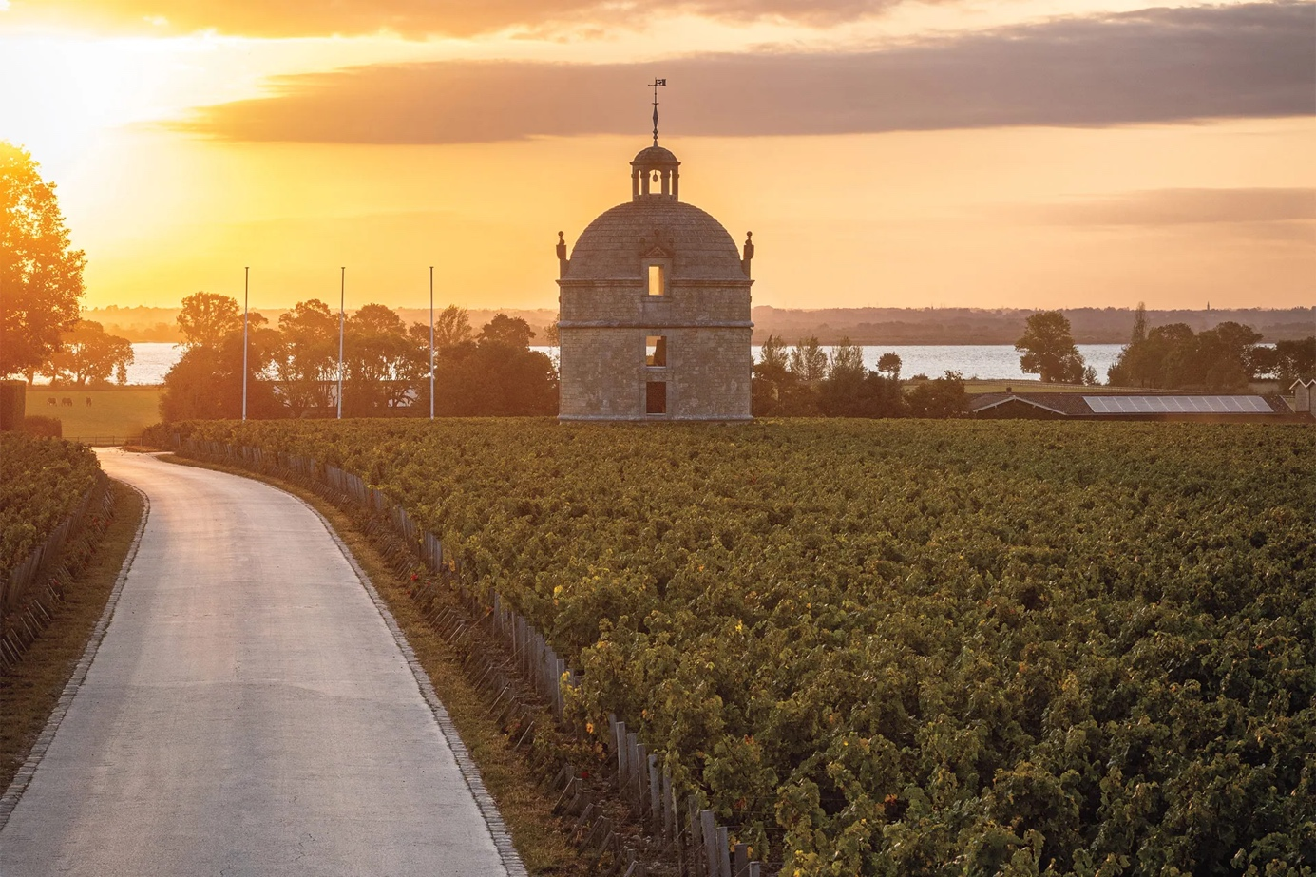Château Latour / Photo by François Poincet

Château Latour

Power, Precision and Purity
Of the four first growths in the Médoc, Château Latour is the one that’s gone furthest with organic and biodynamic methods. Owned by the Pinault family of luxury products empire Kering (the group that manages Gucci, Alexander McQueen, Saint-Laurent and more) since 1993, all of its 229 acres have been certified organic for the last two years.
The heart and jewel of the vineyard is the 113 acres of the walled L’Enclos, the source of Latour’s famed Grand Vin. That block is now biodynamic, one of the largest areas of biodynamics in Bordeaux.
“We do notice greater intensity in the fruit, perhaps more energy in the wine,” says Jean Garandeau, sales and marketing director at Latour, when asked what effect biodynamics has on the vineyard. “We are certainly pleased with the results in the health of the vineyard.”
The L’Enclos, at the southern limit of Pauillac, dates at least to the 17th century. The vineyard’s proximity to the Gironde estuary, less than half a mile away and very visible, is what makes it so vital to Latour’s wine. That creates a microclimate where temperatures are two or three degrees warmer in the winter than the rest of the vineyard.
Gravel and clay, drained since the 18th century, make “a perfect spot for Cabernet Sauvignon,” says Garandeau. Today, Cabernet makes up at least 90% of the Grand Vin.
There are three elements to the style of Latour: the precise quality of the tannins, the aromatic purity that comes from the transparency between the land and wine, and the power in its length and complexity.
It’s austere sometimes at the beginning, but it deepens as it matures. The style of Latour has always been conducive to aging. The combination of the L’Enclos vineyard and biodynamics has further refined and defined this essential character, a wine for the generations.
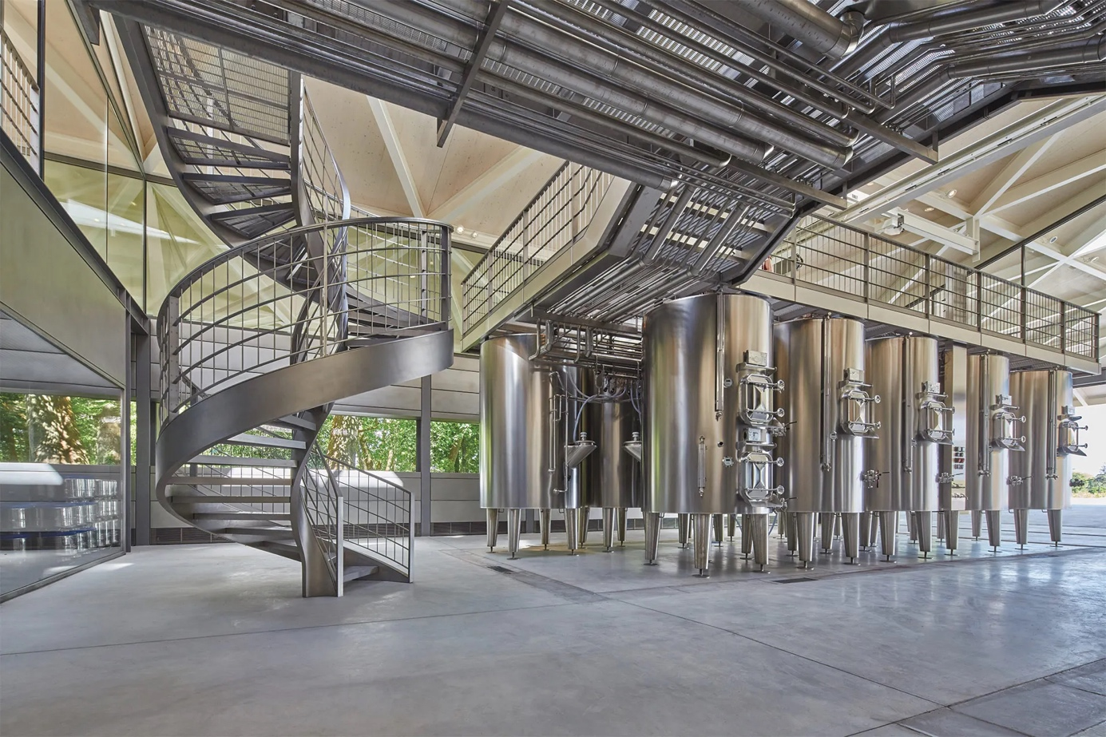Château Margaux / Photo by François Poincet

Château Margaux

Finesse and Elegance
Continuity and attention to detail keep Château Margaux at the top of its game.
The southernmost of the four Médoc first growths, it’s known for its grand, classical chateau, an impressively distant vista at the end of a long avenue of trees. When she’s in Bordeaux, this is the home of Château Margaux owner Corinne Mentzelopoulos.
The chateau is at the heart of the 654-acre estate, which is made up of woods and fields. Some 252 of those acres are under vine. The vineyard, with records that date to the 16th century, is the same today as it was then. Merlot vines start as the fields by the Gironde begin to slope up.
Just to the north of the chateau is the walled vineyard at the heart of the Grand Vin, planted to Cabernet Sauvignon. This, says Philippe Bascaules, the director of Château Margaux since 2016, “gives the perfect wine and makes at least 70% of the Grand Vin.”
Both in the vineyard and cellar, Bascaules describes an almost fanatical attention to detail.
“We have divided the original parcels into four, and each microparcel has its own character,” he says.
That’s why there are now 95 tanks in the cellar, with 30 more in the works. In the new cellar, designed by leading architect Norman Foster, the rows of tanks seem to stretch far into the distance.
“We want to treat each micro-parcel individually,” he says. “We are observing our vineyard over the long-term. We have the time.”
The wine that comes from this ancient vineyard has always been known for its elegance. New approaches, which include organic practices as much as possible, have resulted in greater definition of the wine. “Everything is in balance,” says Bascaules. “It is not the intensity of one or other element, but the combination that makes Château Margaux and its perfume, the softness of the tannins that are at its heart.”
The increased use of Cabernet Sauvignon in the blend has not changed the primary character of Château Margaux. The tannins may be a tad more intense, but then so are the perfume and the velvet, the harmony and the gentle concentration.
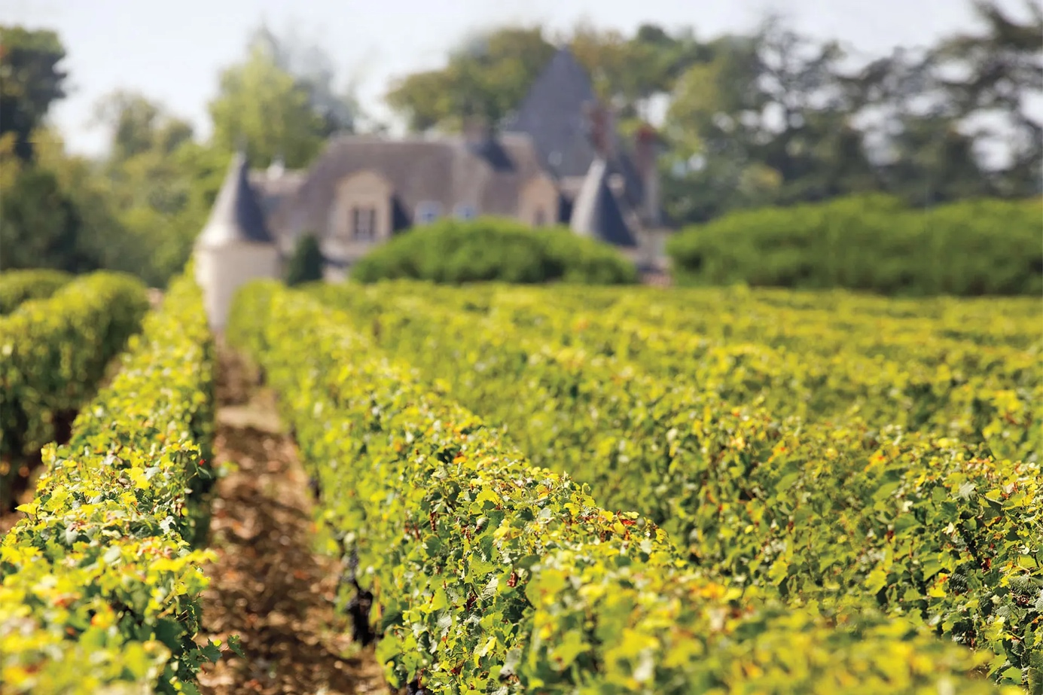Château Haut-Brion / Photo by François Poincet

Château Haut-Brion

The Historical Exception
Of the five first growths, Château Haut-Brion is the outlier. It’s in the first area of vines planted in the Bordeaux region. Its vineyard is an oasis of green amid the suburban sprawl of universities, hospitals and housing, rather than in open country close to the Gironde estuary. It has more Merlot in the blend than other first growths.
It also has the longest history. Local records extend to the 16th century. The wood-lined library that houses the chateau’s archives was created by the current president of the estate, Prince Robert of Luxembourg, grandson of American Clarence Dillon, who bought the chateau in 1935.
A coin of first-century Emperor Claudius found in the vineyard suggests it could first have been planted by the Romans, who were viticulturally active in Bordeaux, says deputy managing director JeanPhilippe Delmas, who has been at Haut-Brion since 2003.
“Haut-Brion has an ecosystem that stems from its history,” he says.
“We also have extraordinary continuity, with only five owners in the last five centuries. I am the third generation of my family to manage the estate on behalf of the Dillon family.”
The ecosystem in question is the alchemy of the soil, the subsoil and the climate. The company is studying the microbiology of the soil and how it affects the different parcels.
“The magic of Haut-Brion is that we have this great terroir, sanctified by time, so we hardly have to interfere during vinification,” says Delmas.
The vineyard slopes gently southward, with gravel over large rocks. The terroir is reflected in the wine, austere when young with a strong line of tannins. Delmas describes the complexity of aromas when the wine is still in the tank. He says they can always find the leather, coffee and toastiness in the young wine.
In a row of first growths, it’s always easy to pick Haut-Brion out of a blind tasting because of its high percentage of Merlot. The grape represents 40% of the vineyard. Merlot gives the wine its richness and generosity once it has begun to mature, which continues the line of history that surrounds this ancient estate.
Last Updated: May 8, 2023

