Bordeaux Vineyard Lose Half Their Value
In large parts of Bordeaux vineyards can be bought for 45% less than five years ago. Elsewhere in France some specific appellations fared far better than others.
Reading time: 3m 45s
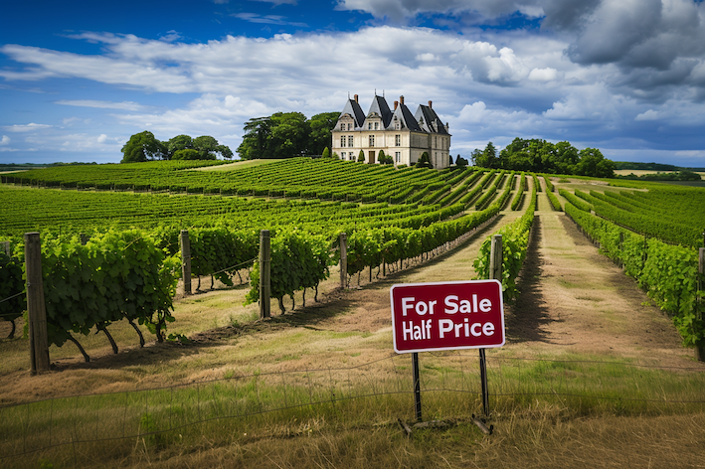
Imaginary Bordeaux vineyard. Image by Midjourney AI
Before anyone rushes to Pauillac or Pomerol with their chequebooks, we are talking about the land where basic Bordeaux Rouge is produced but, as the latest official Groupe Safer report reveals, bargain hunters will also find that the average price of Médoc vines was 29% lower in 2023 than the previous year and there has even been a 10% fall in the value of Pessac-Léognan.
Serious investors and potential shareholders read annual company reports carefully. Few wine professionals see themselves as stockholders in their local, let alone global, industry, so little attention is paid to the comparable reports issued by countries and regions. But, like workers in any sector, their livelihoods depend on its general wellbeing. And, given France’s central role in the wine industry, the official 2023 report by Groupe Safer, the not-for-profit agency with responsibility for tracking all of France’s agricultural land transactions, is worth some consideration.
It probably should matter to quite a few people in the industry that AOP Bordeaux Rouge vineyards are worth just €9,000/ha ($4,000/acre) little more than half as much as they were five years ago. Or that French supermarket shoppers bought nearly10% less red wine last year than in 2022. Or that AOP prices have dropped by the same amount compared to the five-year average. All of these pieces of data are symptoms of a fast-changing environment.
According to Safer, last year was not generally a success for the French wine sector. A harvest that was 8% larger than the average of the last five years may explain why stocks of AOP wine were 6% higher at the end of 2023 than a year earlier, but not why they had risen by 26% and 29% respectively for IGP wines and ones without regional designation. This surplus was, the report states, due to a slowdown of demand, ‘especially in the domestic market’.

Falling sales
During 2023, French supermarket shoppers bought 9% less red wine. The fall in sales of white and rosé were less significant but, overall, still wine sales in these outlets dropped by 4%.
Exports fell too – by 4% in volume and 10% in value. The poorest-performing markets was China - down by around 30%, with Bordeaux specifically losing over a quarter of its sales there across a 12 month period. Japan was nearly as bad, followed by the US and UK.
Lower demand leads to lower prices, so it is not surprising that AOP prices – apart from Champagne - fell by 13% when compared to 2022, and were 9% lower than the five year average. These numbers matter when one considers that French inflation over the whole of this period was nearly 14%.
Land ownership is changing too. In 1993, vignerons – grape farmers – owned nearly two thirds of France’s vineyards and over half of viticultural land value. In just thirty years those figures have plummeted respectively to 35% and just under 16%. The image of French wine being produced by ruddy-faced peasants needs to be seriously revised. Over the three decades, adjusting for inflation, viticultural businesses have made five times the acquisitions, bought 6.5 times as much land and invested nine times as much money as them.

Appellations as brands
Analysis of land prices reveals very clearly how some appellations are ‘brands’ with a value that continues to rise, while others are clearly not. So, while land prices in the Loire rose by less than 2%, those of Saumur leapt by 19%. In the diverse Bourgogne-Savoie-Jura region, which saw an overall rise in value of 8% (following a similar hike in 2022), the engines have been the Côte d’Or (especially Premier Cru whites), Côtes du Jura and L’Etoile. Anyone who bought a Côtes du Jura vineyard a few years ago made a wise investment; its value may have gone up by nearly a fifth over a period of just 12 months.
In Languedoc, however, the popularity of Pic St Loup and Picpoul de Pinet with buyers, could not save the AOPs in this vast region from collectively losing 4% of their value. In the Rhône, the successful outliers were Châteauneuf-du-Pape, and St Joseph whose value rose by an impressive 17%
Until 2022, the price of Bordeaux land – with the exception of a few appellations – rose fairly steadily every year. Then it fell by 3%, followed by a further 4% last year. A tighter focus reveals just how meaningless this overall figure is, though. The top left bank appellations - Pauillac, Saint-Julien and Margaux – all held their value while around them prices tumbled – by 17% in the Haut-Médoc and 29% in the Médoc. Even Pessac-Léognan saw a 10% fall. Most dramatic, though, was that halving of the value of Bordeaux rouge.
The contrast in the recent fortunes of Bordeaux and France’s non-AOP land is striking. Over the first decade of this century, the value of the latter fell by over a quarter, but most of this was recovered over the following 12 years, thanks in large part to the revival of Languedoc IGPs. Whether these will hold their value, is uncertain, however, given the current volumes of unsold stock.
All data needs to be treated with caution, and Safer would admit that its figures are based on transactions over a given period of time. There were fifth fewer land sales in Bordeaux in 2023, and clearly, in any year, a few big or discounted transactions in a small appellation can create an unrepresentative impression. But the quarterly and annual reports corporations prepare for their shareholders can be similarly skewed by extraordinary factors. Wise investors – like anyone planting vines or maturing wine – have to look at the longer term. And the longer term for appellations that have not created brand value is not looking too bright.
Tags
Bordeaux

