Golden State Gamay Is Here to Stay
BY MATT KETTMANN THE WINE ENTHUSIAST
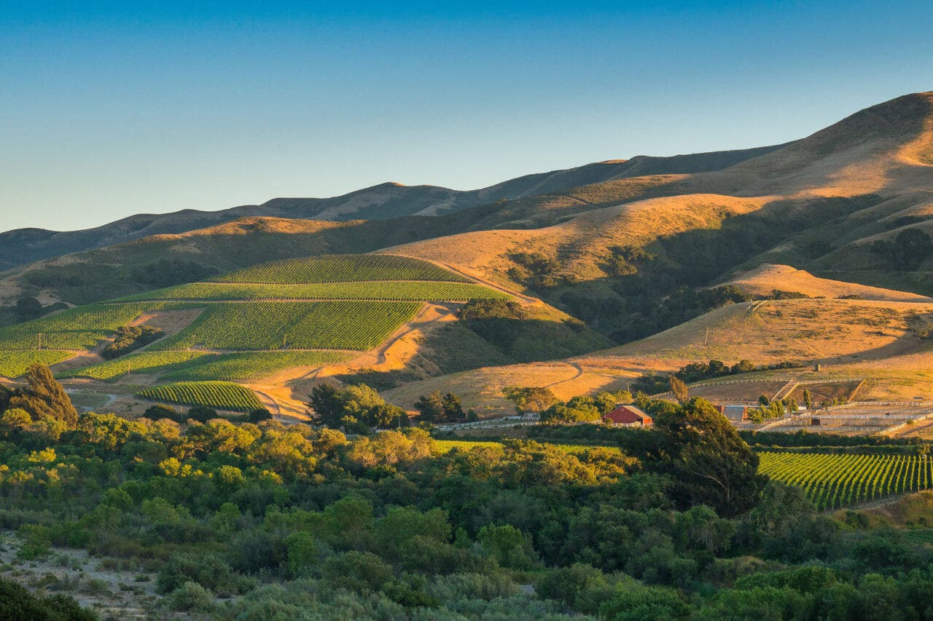
Donnachadh Estate Vineyard – Image Courtesy of Drew Duncan

Just five years ago, Gamay Noir was the newest kid on California’s fine-wine block, with just a handful of producers giving this zesty, lighter-bodied red grape from Beaujolais the good ole Golden State try. Today, with an increasing number of vines being planted from Sonoma to Santa Barbara and more wineries crafting their own versions, Gamay appears here to stay. Winemakers appreciate the grape’s versatility, both in the vineyard and on the table. As for consumers? They might be most elated to have found something new.
“By the bottle, it might be the best seller in our tasting room,” says Donnachadh Family Wines owner Drew Duncan, who became an early adopter when he planted own-rooted Gamay on his Sta. Rita Hillsvineyard in 2016. “People don’t realize it’s just what they’re looking for until they taste it—and then the light goes on. People seem delighted by the balance, how the fruit, spice, earth and acid all come together in such an effortless way.”
You May Also Like: Grapes That Wish They Were Pinot Noir
Ernst Storm makes Gamay from that property, as well as Presqu’ile Vineyard in the Santa Maria Valley, the latter of which was his first stab at the grape in 2019. “It is not as serious as Pinot Noir, so inexperienced wine drinkers tend to not be intimidated by it,” says Storm. He serves his Gamay slightly chilled as a bridge between whites and reds at his Storm Wines tasting room in Los Olivos. “They like the fact that it is more fun and approachable, easy to understand but with a lot of depth.”
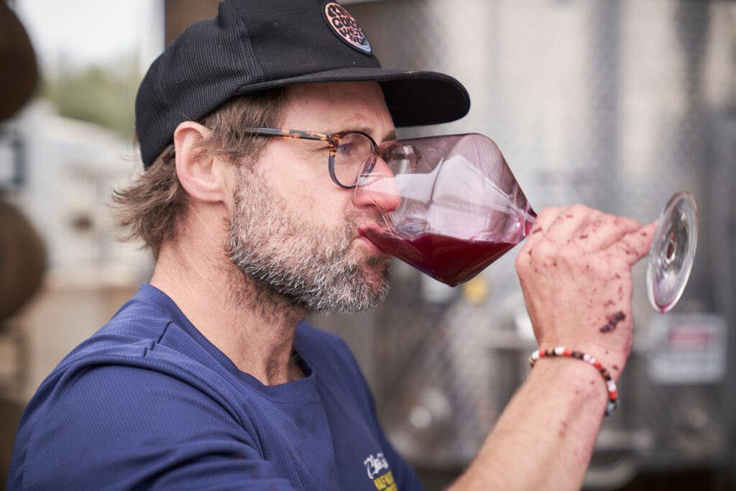ERNST STORM TASTING WINE – IMAGE COURTESY OF STORM WINES
In Santa Cruz, Cole Thomas of Madson Wines uses his Gamay as a “vin de soif,” aka a thirst-quencher. He started with two barrels in 2021, opting for a whole-cluster, herb-forward but bright-fruit style. “Whole-cluster Gamay doesn’t need years in the cellar to be interesting,” he says. “Our consumers are interested in lighter reds that they can bring to a BBQ or serve chilled as an afternoon aperitif.”
You May Also Like: How Beaujolais Nouveau Won (And Lost) Generations of U.S. Drinkers
Scott Caraccioli of Caraccioli Cellars, meanwhile, is finding a lot more depth to the grape, which he grafted into his family’s Escolle Vineyard in the Santa Lucia Highlands four years ago. He’d been drinking a lot of Beaujolais and wanted to see it through a California lens. “I was not anticipating the density and complexity it would pull from the granite,” says Caraccioli of his property’s soils.
For a learning experience in his Carmel tasting room, he pours the Gamay right before the Syrah. “The geologic influence on both the Gamay and Syrah make that transition decipherable from a site perspective,” explains Caraccioli, whose customers became immediate fans. “It’s an incredibly giving wine, so it’s rewarding to see the smile after the first sip.”
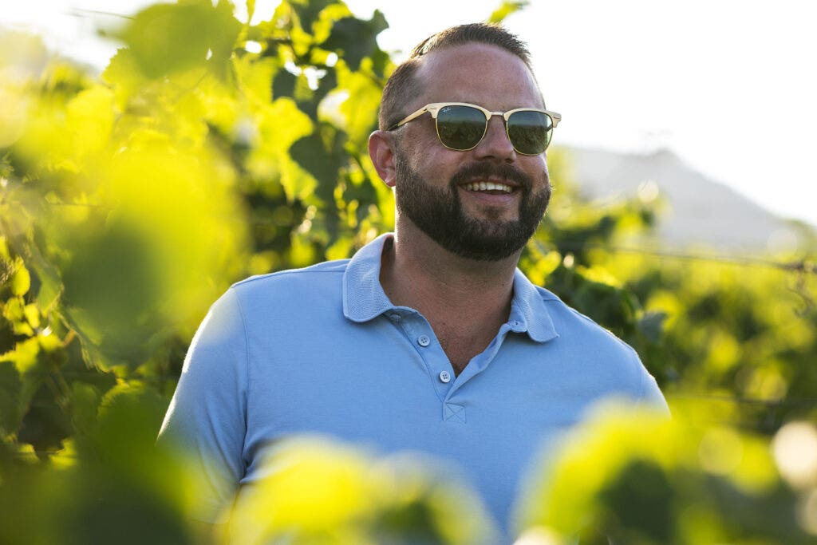SCOTT CARACCIOLI – IMAGE COURTESY OF LEIGH ANN BEVERLEY
Gamay can show a darker side as well. Before becoming general manager of her family’s Pellegrini Wine Company at Olivet Lane Vineyard in the Russian River Valley, Alexia Pellegrini imported wines for Beaujolais producer Maison Jean Loron, which taught her how Gamay can be handled in different ways. Finding any Gamay to buy in Sonoma was tough at first. She and her team located a stable vineyard in the Knights Valley and planted their own in 2021 and soon after grafted over 500 more vines. Then they decided to make a denser version.
“Though Gamay is typically one-half step lighter on the spectrum, our utilization of submerged cap vessels throughout fermentation leads to a richer profile,” says Pellegrini, who pours her Gamay after their Pinots in the tasting room.
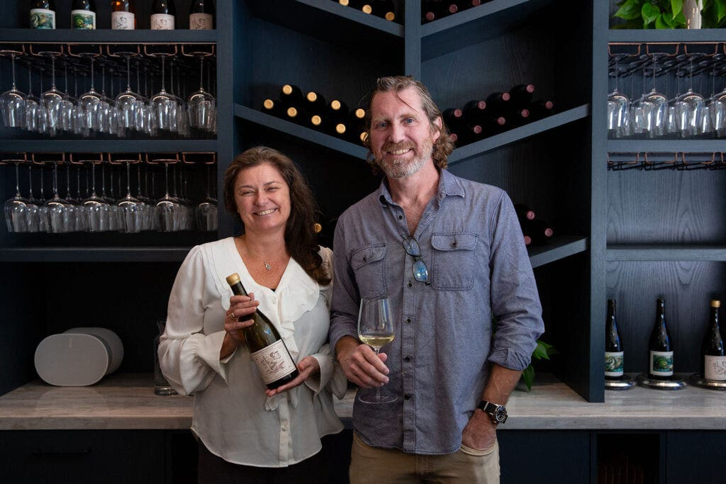DREW AND LAURIE FROM DONNACHADH FAMILY WINES – IMAGE COURTESY OF CLAIRE E HARTNELL PHOTOGRAPHY
That style helps with challenging pairings, says Pellegrini’s winemaker Charlie Fauroat, who likes it with savory-sweet Chinese roasted meats and tomato-based Indian curries. “While it is deep, brooding, blue fruited and bold, it also presents with soft rounded tannin structure, has the potential for remarkable aromatic prettiness and intensity,” he says. “I love what an outlier Gamay can be.”
You May Also Like: As Climate Change Drives Up Temperatures, Winemakers Climb Higher
There’s another reason Gamay may find its way to your glass for years to come. “Climate change is a big reason I believe Gamay is here to stay,” says Chris Pittenger, co-owner and winemaker of Gros Ventre Cellars, which produces Gamay from Santa Barbara to the Sierra Foothills. “Many areas that used to be prime for Pinot Noir are simply not ideal today or won’t be in the next 20 years. Gamay has a thicker skin and can handle warmer temperatures while keeping its natural acidity.”
Replanting is already happening in these warmer spots, and there’s more Gamay on the market every year. “I believe we are in the first inning of a great baseball game,” says Pittenger. “I look forward to watching the Gamay game play out in California, Oregon and beyond.”
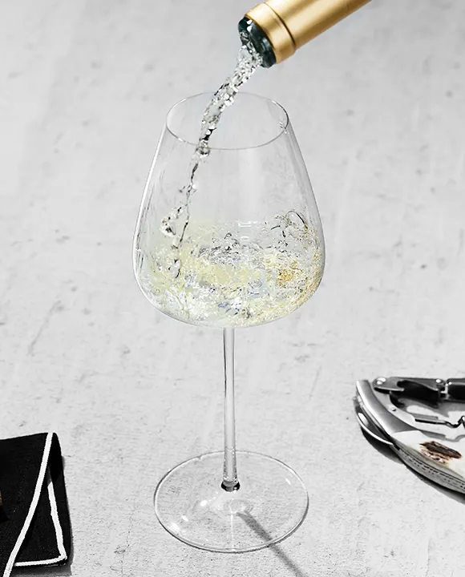
FROM THE SHOP

